Task 1:
SOHO Network Topology & Architecture Diagram

Objective: Design and document a Small Office/Home Office (SOHO) network topology detailing all interconnected host endpoints, boundary network hardware, and underlying transmission media (Wired Ethernet vs. Wireless Wi-Fi).

1. Text-Based Network Topology Diagram:

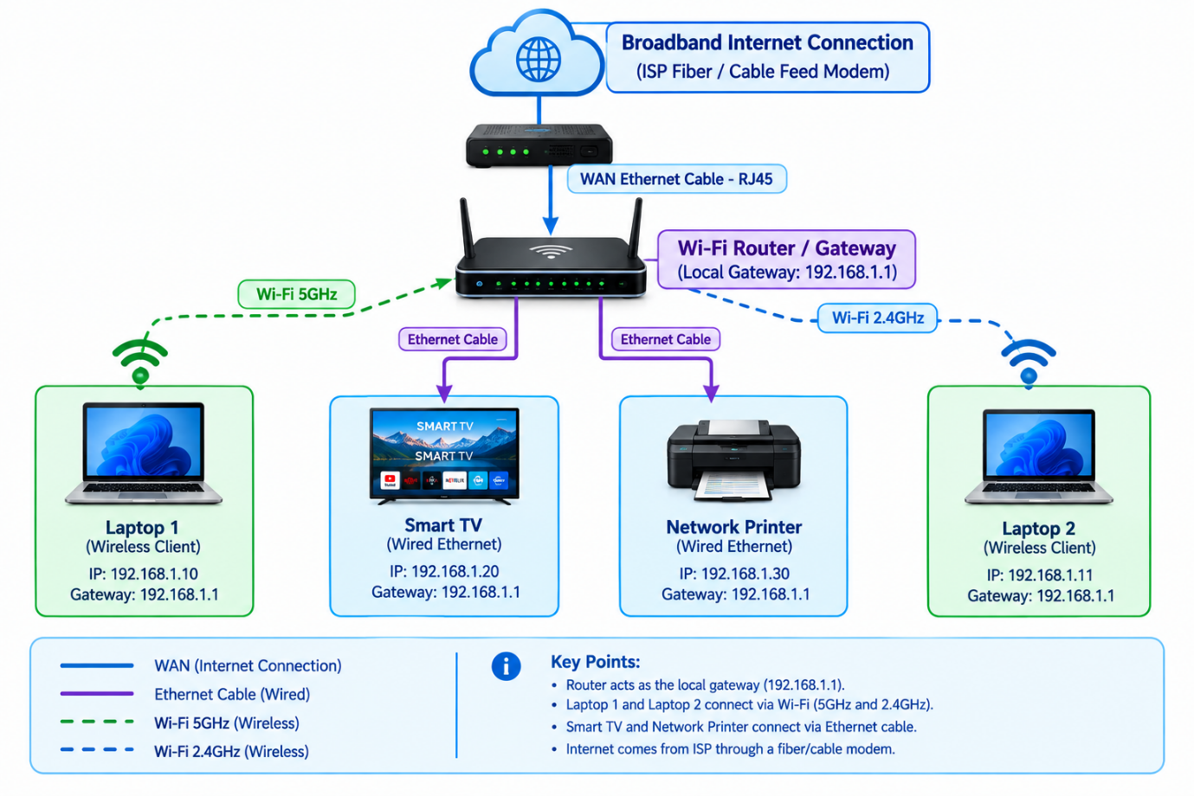

2. Device Connection Matrix & Media Specifications:

Device Name | Device Category | Physical / Logical Connection Type | IP Allocation Strategy | Rationale for Connection Type
ISP Modem / Connection | WAN Boundary | Wired Ethernet (RJ45 WAN Port) | Public IP (DHCP/PPPoE) | High-speed backbone connection from Internet Service Provider.
Wi-Fi Router | Network Gateway | Central Router Node | 192.168.1.1 (Static Gateway) | Handles NAT, Routing, DHCP distribution, and Firewall inspection.
Smart TV | Entertainment Host | Wired Ethernet (Cat6 Cable) | Static IP (192.168.1.50) | Ensures buffer-free 4K video streaming without wireless signal decay.
Network Printer | Shared Peripheral | Wired Ethernet (Cat6 Cable) | Static IP (192.168.1.100) | Ensures constant network availability and reliable print job queuing.
Laptop 1 | Mobile Workstation | Wireless Wi-Fi (5 GHz Band) | Dynamic DHCP (192.168.1.101) | High mobility with maximum data transfer speeds for work tasks.
Laptop 2 | Mobile Workstation | Wireless Wi-Fi (2.4 / 5 GHz) | Dynamic DHCP (192.168.1.102) | Flexible wireless connectivity across home/office locations.

Task 2:
Hardware Component Specifications & Bill of Materials (BOM)

Objective: Itemize all essential physical hardware components, network infrastructure equipment, cables, and client devices required to deploy the SOHO network based on standard Indian office/home market availability.

Hardware Component & Device Model List Table:

Component Category | Device Name | Suggested Brand & Model | Specifications & Ports | Connection Role
WAN Modem | Optical Network Terminal (ONT) / Fiber Modem | Syrotech / Digisol XPON ONT | 1x PON Port, 1x GE LAN Port | Terminating Airtel/Jio Fiber ISP line.
Central Wireless Gateway | Dual-Band Wi-Fi 6 Router | TP-Link Archer AX12 / AX10 | Dual-Band (AX1500), 4x Gigabit LAN, 1x Gigabit WAN | Handles NAT, Routing, DHCP, Firewall, Wi-Fi 5GHz & 2.4GHz.
Network Cables | Ethernet Patch Cables (Cat6) | Fedus / Cable Creation Cat6 RJ45 Cables | UTP 1000 Mbps Gigabit support, 24 AWG | Connecting Smart TV, Printer, and ONT to Router LAN/WAN ports.
Network Range Extender (Optional) | Wi-Fi Range Extender | TP-Link TL-WA850RE / RE305 | Dual-Band Mesh Extender with Ethernet port | Extending Wi-Fi coverage to far corners of the office/home.
Shared Peripheral | Network All-in-One Printer | HP Smart Tank 580 / Canon PIXMA G3010 | Built-in Wi-Fi & Ethernet, USB 2.0 | Shared printing/scanning for all network clients via static IP.
Smart Display | Smart LED TV | Xiaomi / Samsung 43" 4K Smart TV | RJ45 Ethernet Port, Wi-Fi 5GHz, Android/Tizen OS | High-definition media presentation and stream endpoint.
Client Laptops (x2) | Mobile Workstations | Dell Inspiron 15 / HP Laptop 15 | Wi-Fi 6 (802.11ax), Bluetooth, RJ45 Dongle/Port | Primary wireless mobile endpoints for daily SOHO tasks.

Summary of Cabling & Connectivity Requirements:

- 1x Cat6 Patch Cable (1 Meter): Connects Fiber ONT Modem WAN port to TP-Link Router WAN port.
- 1x Cat6 Ethernet Cable (3–5 Meters): Connects Router LAN Port 1 to Smart TV Ethernet Port.
- 1x Cat6 Ethernet Cable (2–3 Meters): Connects Router LAN Port 2 to Network Printer Ethernet Port.
- Wireless (Wi-Fi 5GHz/2.4GHz): Connects Laptop 1 and Laptop 2 dynamically via WPA2/WPA3 security.

Task 3:
tep-by-Step Wi-Fi Router Configuration Guide

Objective: Configure essential security, administrative credentials, and wireless network settings on a new SOHO Wi-Fi Router to eliminate default security vulnerabilities and enable encrypted wireless access.

1. Step-by-Step Router Configuration Procedure:
1.Connect to the Router & Access Management Dashboard:Step 1.
- Connect a PC or Laptop to one of the router's LAN ports using an Ethernet cable (or connect via default Wi-Fi printed on the router label).
- Open a web browser (e.g., Google Chrome) and enter the default gateway IP address: 192.168.1.1 (or 192.168.0.1).
- Enter the factory default admin credentials (e.g., username: admin, password: admin) to log into the management console.
2.Change Default Administrator Password:Step 2.
- Navigate to System Tools > Administration (or Maintenance > System Management).
- Select Change Admin Password.
- Enter the current default password (admin).
- Set a strong new administrative password (minimum 12 characters including uppercase, lowercase, numbers, and special symbols, e.g., Admin@SOHO#2026!).
- Click Save / Apply.
3.Configure Unique Wireless SSID:Step 3.
- Navigate to Wireless > Basic Wireless Settings.
- Set the Wireless Network Name (SSID) for the 2.4 GHz band to: SOHO_Office_2.4G.
- Set the Wireless Network Name (SSID) for the 5 GHz band to: SOHO_Office_5G.
- Ensure Enable Wireless Router Radio is checked and set Channel Width to Auto / 40MHz for maximum throughput.
4.Enable WPA2 / WPA3 Wireless Security Encryption:Step 4.
- Navigate to Wireless > Wireless Security.
- Select WPA2-Personal (WPA2-PSK) or WPA2/WPA3-Personal Mixed Mode as the security version.
- Set Encryption Type to AES (Advanced Encryption Standard).
- Set a complex Wireless Password / Pre-Shared Key (PSK) (e.g., SOHO@SecurePass2026).
- Click Save and reboot the router to apply all changes.

2. Security Best Practices Verification Checklist:

Configuration Parameter | Factory Default State | Configured Production State | Security Benefit
Admin Panel Password | admin / password | Admin@SOHO#2026! | Prevents unauthorized local users from modifying router settings.
Wireless SSID | TP-Link_XXXX / Netgear | SOHO_Office_5G | Prevents device profiling and identifies the specific office network.
Security Mode | Unsecured / Open | WPA2-PSK (AES) | Encrypts over-the-air traffic to prevent packet sniffing and eavesdropping.
WPS (Wi-Fi Protected Setup) | Enabled | Disabled | Eliminates PIN brute-force vulnerabilities.

Task 4:
IP Address Allocation Plan & MAC Address Table

Objective: Design a mixed IP allocation scheme for the SOHO network by assigning permanent static IP addresses to critical infrastructure devices (Printer & Smart TV) and enabling dynamic DHCP IP distribution for mobile endpoints (Laptops).

1. SOHO Device IP Allocation & MAC Address

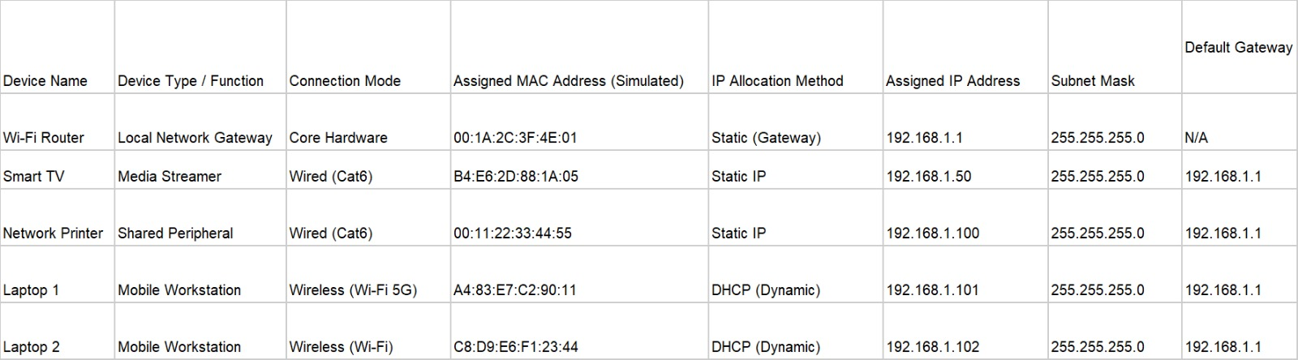

2. DHCP Server Scope Configuration Parameters:
- Gateway IP Address: 192.168.1.1
- Subnet Mask: 255.255.255.0 (/24)
- DHCP Address Pool Range: 192.168.1.101 to 192.168.1.200
- Static Reserved Range: 192.168.1.2 to 192.168.1.99 (Reserved for Static Servers, Printers, Smart TVs, and IoT Gateways)
- Primary DNS Server: 8.8.8.8 (Google Public DNS)
- Secondary DNS Server: 1.1.1.1 (Cloudflare DNS)

Task 5:
SOHO Laptop Network Connectivity Troubleshooting Guide

Objective: Document a structured troubleshooting methodology to diagnose and resolve internet connectivity failures on a SOHO laptop by analyzing 3 distinct root causes across physical, network, and transport layers.

Systematic Diagnostic Flowchart:

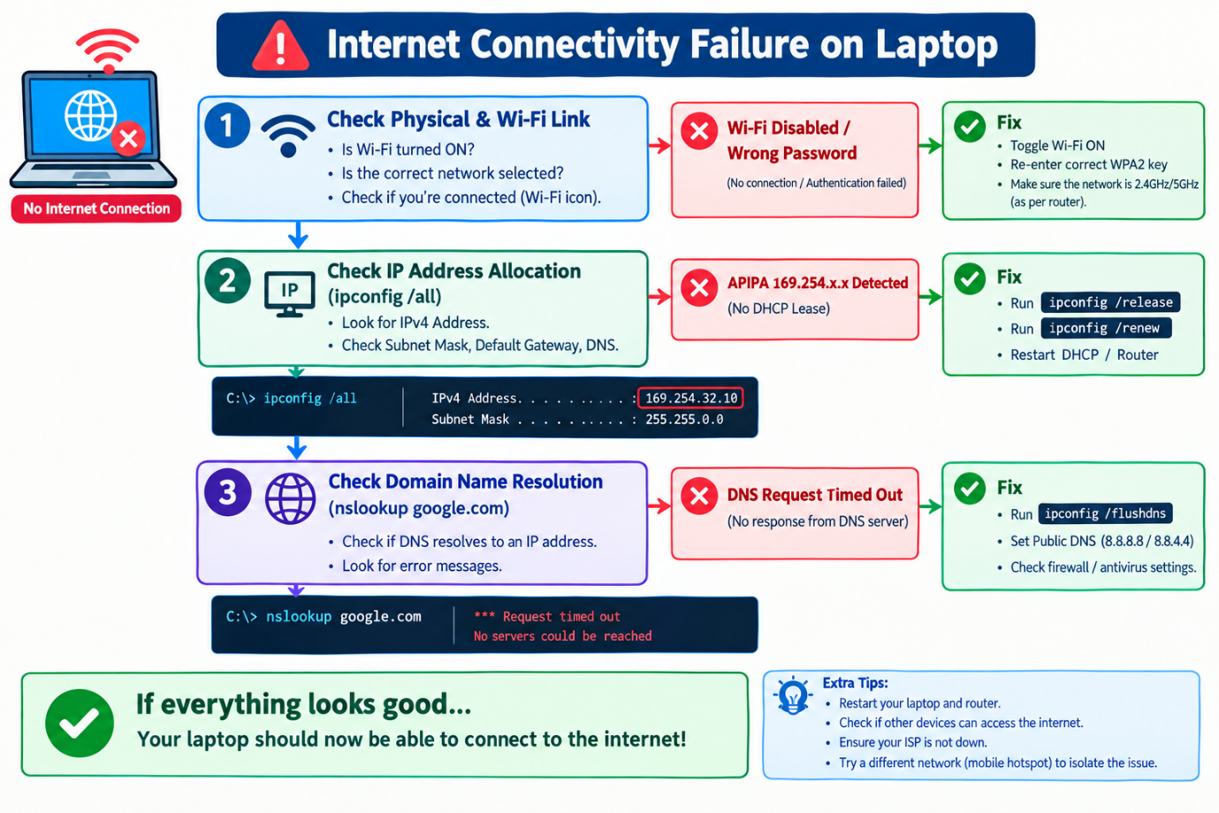

Troubleshooting Matrix: 3 Causes, Diagnostics & Fixes

# | Root Cause | Diagnosis Method | Step-by-Step Resolution / Fix
1 | DHCP IP Allocation Failure (APIPA IP Assigned) | Open Command Prompt and run ipconfig. If the IPv4 address shows 169.254.x.x, the laptop failed to obtain an IP from the SOHO router's DHCP server. | 1. Run ipconfig /release followed by ipconfig /renew.2. If unsuccessful, log into the router dashboard (192.168.1.1) and verify DHCP pool availability.3. Restart the router to clear DHCP lease locks.
2 | DNS Resolution Failure (Cannot Resolve Web Addresses) | Executing ping 8.8.8.8 succeeds with replies, but ping google.com fails with "Could not find host". | 1. Clear DNS cache by running ipconfig /flushdns in CMD.2. Open Network Adapter Settings -> IPv4 Properties.3. Manually assign Primary DNS: 8.8.8.8 and Secondary DNS: 1.1.1.1.
3 | Wi-Fi Adapter / Security Authentication Issue | Laptop shows "No Internet, Secured" or fails to authenticate to the SSID SOHO_Office_5G. | 1. Forget the Wi-Fi network and reconnect using the correct WPA2 key (SOHO@SecurePass2026).2. Toggle Airplane Mode ON/OFF or reset the Wi-Fi adapter (netsh winsock reset).3. Update or reinstall the Wi-Fi Network Adapter driver via Device Manager.

